**CS 323 Exam 1**

**Problem 1**

1. 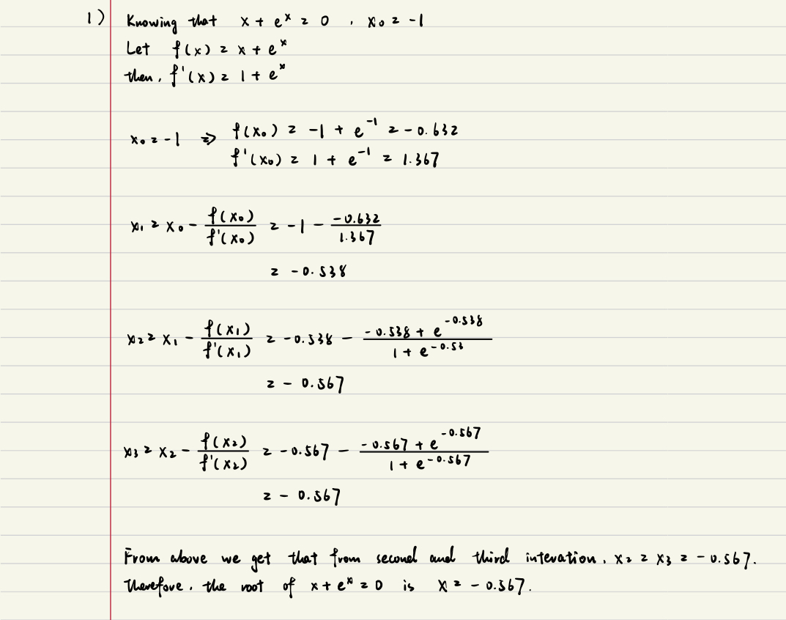
2. 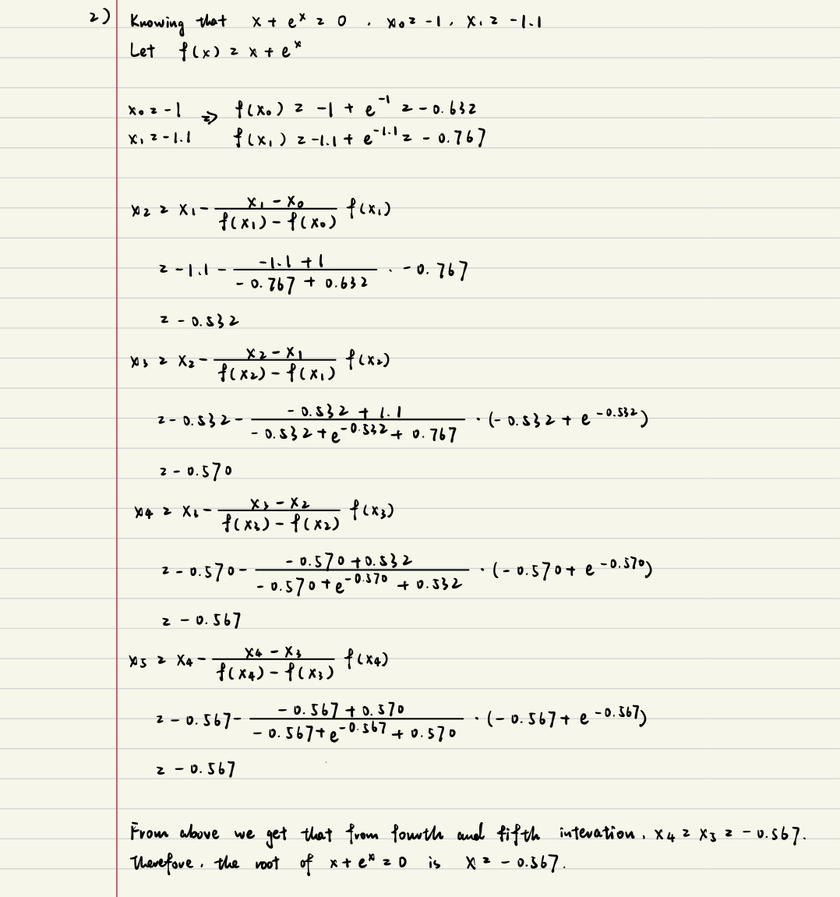
3. 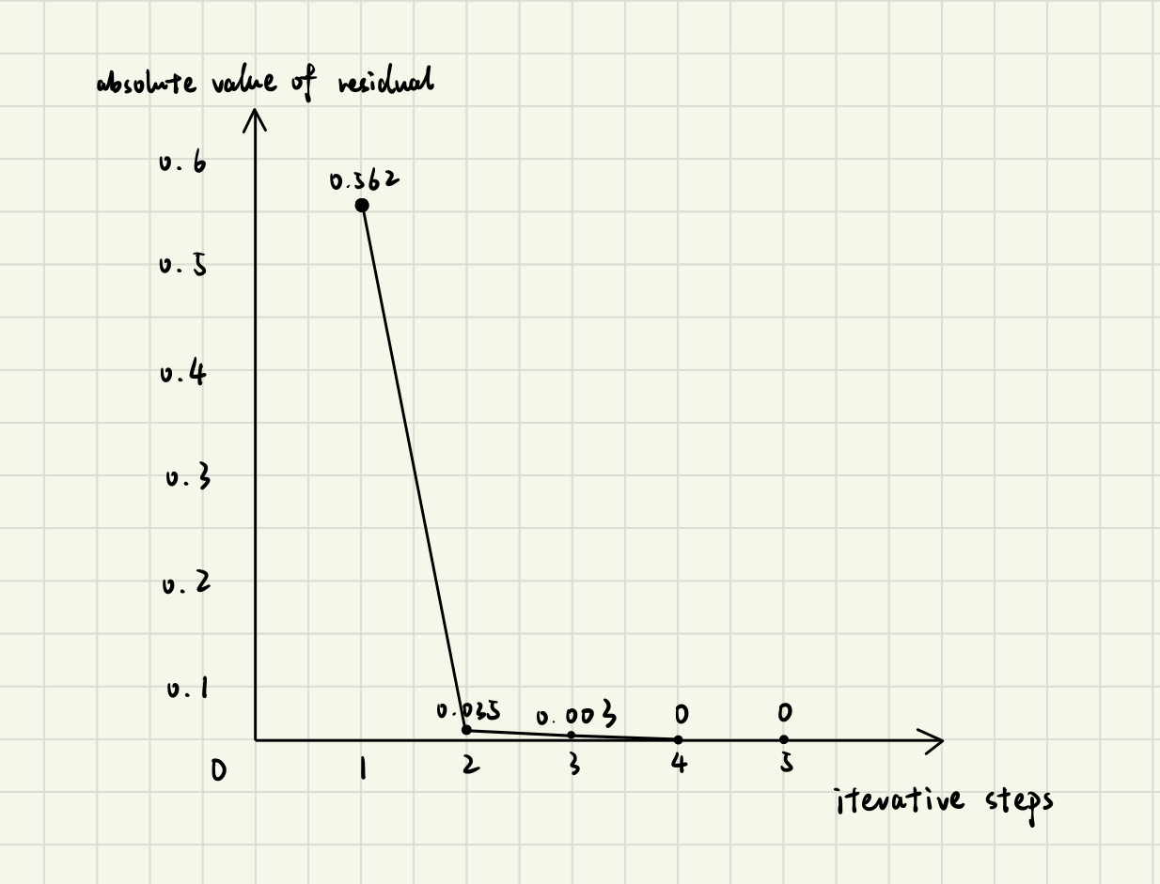

**Problem 2**

1. L1 norm of Jacobi: 49.963397
2. L∞ norm of Jacobi: 0.050000
3. L2 norm of Jacobi: 1.580103
4. L1 norm of GS: 49.963397
5. L∞ norm of GS: 0.050000
6. L2 norm of GS: 1.580103
7. L1 norm of SOR: 49.963397
8. L∞ norm of SOR: 0.050000
9. L2 norm of SOR: 1.580103
10. 